Raymond Shiner

Lab5

Databases

----------------------------------------------------------------------

1.

Select title, retail

From Books

Where retail <

(select avg(retail)

From Books);



2.

select title, category, cost

from BOOKS a natural join

(select category, avg(cost) averageCost from BOOKS group by category) b

where cost < averageCost

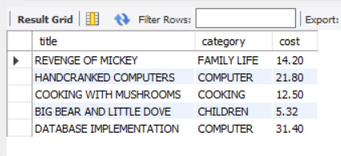

3.

select order_num

from ORDERS a, (select shipstate from ORDERS where order_num = 1014) b

where a.shipstate = b.shipstate;

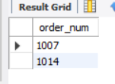

4.

select order_num, sum(quantity * paideach) as amount

from ORDERITEMS

group by order_num

having amount > (select sum(quantity*paideach) from ORDERITEMS where order_num = 1002)

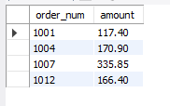

5.

select distinct book.title

from BOOKS book,

(select category from BOOKS natural join ORDERITEMS natural join

(select order_num from ORDERS where customer_num = 1007)a group by category) b

where book.category = b.category and book.title not in (select title from BOOKS

natural join ORDERITEMS natural join (select order_Num from ORDERS where customer_num = 1007) c);



6.

select shipcity, shipstate

from ORDERS

where datediff(shipdate, orderdate) =

(select max(datediff(shipdate, orderdate)) from ORDERS)



7.

select customer_num

from ORDERS

natural join ORDERITEMS

natural join (select ISBN from BOOKS

where retail = (select min(retail) from BOOKS)) a

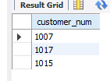

8.

select count(distinct customer_num)

from ORDERS natural join

ORDERITEMS natural join

BOOKS natural join (select ISBN from BOOKAUTHOR natural join AUTHOR

where Fname = 'James' and Lname = 'Austin') a

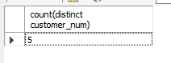

9.

select product_name, list_price

from products

where list_price > (select avg(list_price) from products)

order by list_price desc

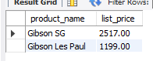

10.

select category_name

from categories c

where NOT EXISTS

(select category_name from products p where c.category_id = p.category_id)



11.

select email_address, order_id, order_date

from orders natural join customers c

where order_date = (select min(order_date)

from orders where c.customer_id = orders.customer_id);

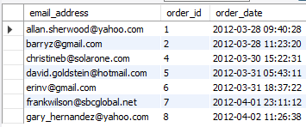

12.

select ID, name, salary

from instructor

where salary = (select max(salary) from instructor)

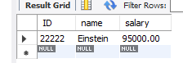

13.

select ID, name, salary

from instructor

where salary = (select max(salary) from instructor

where salary < (select max(salary) from instructor))

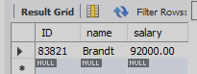

14.

select ID, name, numClasses

from instructor natural join

(select ID, count(distinct course_id) as numClasses from teaches group by ID) sub

where numClasses >= all((select count(distinct course_id) from teaches group by ID));

